
Test Automation Keywords

Version 2.0
January 02, 2014

Created for:
ETC Internal

Document History
Date | Revision Version | Author | Summary of Changes
01/02/2014 | 1.0 | Nagappa Batikeri | Initial Document
06/18/2014 |  | Hieu Nguyen | List out the purpose and how to use for Backend and UI keywords (55 keywords are being used now)

Table of Contents

1 Overview 1
1.1 Purpose 1
2 Definitions, Abbreviations 2
3 Backend Automation Keywords 3
3.1 read_msg 3
3.2 call_proc1 3
3.3 find_record 4
3.4 store_input 5
3.5 store_key 5
3.6 store_multi_data 6
3.7 compare_multi_data 6
3.8 compare_exp 7
3.9 compare_params 8
3.10 compare_var 8
3.11 bucket_rule (to be confirmed) 9
3.12 sftp_file 10
3.13 unix_command 11
3.14 dos_command 11
3.15 find_replace 12
3.16 create_file 13
3.17 LC_create_file 13
3.18 insert_steps 14
3.19 wait_time 14
3.20 ui_steps 15
3.21 db_connect 15
3.22 load_multi_data 16
3.23 save_QryResults 17
3.24 webService_call 17
4 Web Automation Keywords 19
4.1 setup_browser 19
4.2 load_page 19
4.3 switch_frame 20
4.4 enter_input 20
4.5 verify_element_present 21
4.6 enter_input_hidden 22
4.7 select_drop_down 22
4.8 count_drop_down 24
4.9 click_element 24
4.10 verify_text 25
4.11 verify_text_contains 25
4.12 verify_field_text 26
4.13 compare_two_var 27
4.14 verify_table_cell_text 28
4.15 table_row_sel 28
4.16 store_cell_data 30
4.17 table_col_sort1 31
4.18 table_col_sort2 32
4.19 switch_alert_ok 32
4.20 compare_JSAlert_msg 33
4.21 page_scroll 33
4.22 screen_shot 34
4.23 wait_time 34
4.24 explicit_wait 35
4.25 store_data 35
4.26 store_input 36
4.27 store_webTable_data 36
4.28 compare_webTable_DB 37
4.29 close_driver 37
4.30 quit_driver 38
4.31 verify_selectbox 38
4.32 verify_checkbox 39
4.33 deselect_drop_down 40
4.34 verify_field_text_contains 40
4.35 store_field_text 41
4.36 concatenate_var 42
4.37 get_text_split 42
4.38 store_webTable_data 43
4.39 compare_webTable_DB 44
4.40 table_RowsCols_count 45
4.41 table_row_del 45
4.42 JSAlert_options 46
4.43 popup_scroll 47
4.44 start_loop 48
4.45 end_loop 48
4.46 enter_input_query 49
4.47 switch_window 50
4.48 screen_shot_popup_window 51
4.49 send_key 51
4.50 select_dropdown_options 52
4.51 hold_ctrl_key 53

Overview

Purpose
The purpose of this document is to install and configure the Test automation framework so that one can setup the tests and run them.

Definitions, Abbreviations

ETC Electronic Transaction Consultants
QA Quality Assurance

Backend Automation Keywords

read_msg

Input | # of input params | Process/Purpose | Output | # of output params
Message string as per ICD in a flat file | None | Read a message one by one from a flat file and store it in an output variable. | Store the raw message in a variable that can be used in next steps. | 1

Test Step Example
Sample Message
RT21,200101,11/19/2013 07:00:05.530,DNT,PARRD,1, ,0,0,11/19/2013 15:00:00,4,0,2,2,2,2,2,0,49,51,01110000,2,99900283,1,2,2,0,0,0,0,0,0,6,0,0,0,0,0,0,0,0,0,0,01/01/1970 00:00:00,0,3,0,0,0,0,0,0,3,2,0,0,0,0,0,0,0,0,64,0,0,0,0

call_proc1

Input | # of input params | Process/Purpose | Output | # of output params
Input Query: PL/SQL block or Procedure/function name | Optional | This keyword logs into the DB and run the given PL/SQL block or procedure. | Pass or Fail | None

Test Step Example

find_record
Input | # of input params | Process/Purpose | Output | # of output params
Expected: input the SQL to return the single row and column | None | Search the record in database | Passed or Failed | None

Test Step Example :
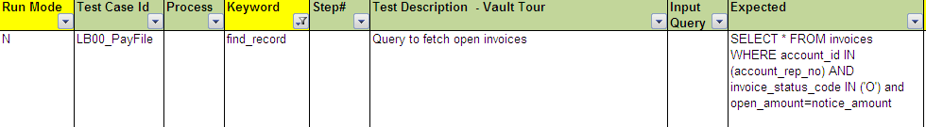

store_input
Input | # of input params | Process/Purpose | Output | # of output params
Expected: value to store in the params | Required | Store the value in Expected to Output Param | Output params | Required

Test Step Example :

store_key
Input | # of input params | Process/Purpose | Output | # of output params
Input Query: input the SQL to return the single row and column | None | Store the value of SQL to the Output Params | The single row and column will be output | Required
Test Step Example :

store_multi_data
Input | # of input params | Process/Purpose | Output | # of output params
Input Params: variables used for querying from DB | Required | Store the output of the query into an array | A variable in array format | Required

Test Step Example :
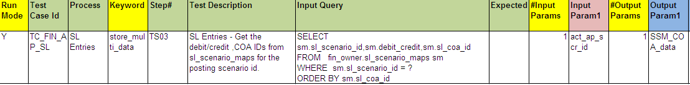

compare_multi_data
Input | # of input params | Process/Purpose | Output | # of output params
Input Params: the output variable from key word store_multi_data | 1 | Compare the input parameter and output parameter. True if they are the same and false for vice versa. | Passed or Failed | 1

Test Step Example :
Run Mode | Test Case Id | Process | Keyword | Step# | Test Description | #Input Params | Input Param1 | #Output Params | Output Param1
Y | TC_FIN_AP_SL | SL Entries | compare_multi_data | TS05 | SL Entries - Compare the debit/credit, COA ids between sl_scenario_maps and sl_transaction_details. | 1 | SSM_COA_data | 1 | STD_COA_data

compare_exp
Input | # of input params | Process/Purpose | Output | # of output params
Input Query: input the SQL to return the single row and column,  Expected: the expected string result,  Input Params: parameter input in SQL | None | Compate result from SQL with the Expected | Passed or Failed | None

Test Step Example :
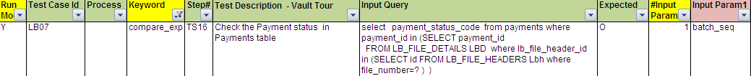

compare_params
Input | # of input params | Process/Purpose | Output | # of output params
Input Params: the compared values | Required | Compare parameters (Input Params) | Passed or Failed | None

Test Step Example :

compare_var
Input | # of input params | Process/Purpose | Output | # of output params
Input Query: input the SQL to return the single row and column,  Expected: expected string value  Input Params: parameters of Input Query | Required | Compare the value in SQL to variable | Passed or Failed | None

Test Step Example :

bucket_rule (to be confirmed)
Input | # of input params | Process/Purpose | Output | # of output params
Payment Type,  AVC Class ID,  Class ID,  Def | None | Apply the bucketing rules to compute the earned_class_id and transaction fare. | Passed or Failed | None

Test Step Example :

sftp_file
Input | # of input params | Process/Purpose | Output | # of output params
Input Query: host name,  Input Params: source and destination | Required | FTP file from local directory to the unix/linux server. | Passed or Failed | None

Test Step Example :
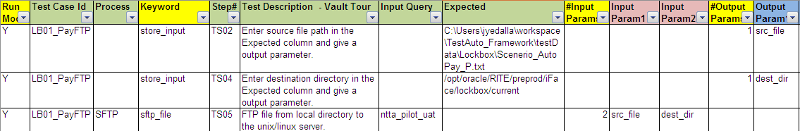

unix_command
Input | # of input params | Process/Purpose | Output | # of output params
Input Query: Host name,  Expected: Unix command want to execute | None | Run the unix command | Passed or Failed | None

Test Step Example :
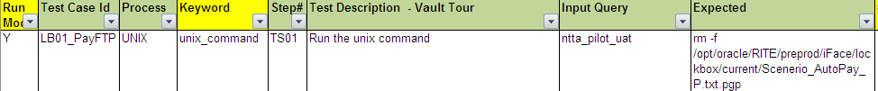

dos_command
Input | # of input params | Process/Purpose | Output | # of output params
Expected: file name path to run in DOS command | None | Run the DOS command specified in “Expected” column. | Passed or Failed | None
Test Step Example :
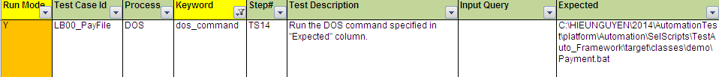

find_replace
Input | # of input params | Process/Purpose | Output | # of output params
Input Query: Text that need to find and replace,  Expected: replaced string,  Input Params: source and destination | Required | Find the text provided in "Input Query" column from given a file and replace with the value provided in "Expected" column. | Passed or Failed | None

Test Step Example :
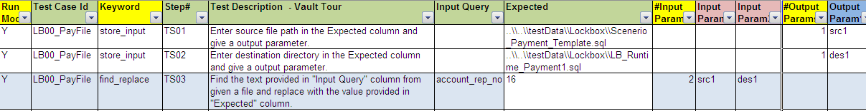

create_file
Input | # of input params | Process/Purpose | Output | # of output params
Input Query: file name,  Expected: the file content | None | Create a file from the ext provide in Expected. | Passed or Failed | None

Test Step Example :

LC_create_file
Input | # of input params | Process/Purpose | Output | # of output params
Input params: the input parameters to create the Lane Controller Plaza file | None | Create the Lan Controller Plaza file with actual data | Lane Controller Plaza file | None

Test Step Example :

insert_steps
Input | # of input params | Process/Purpose | Output | # of output params
Input Query: the spreadsheet contains the steps that want to insert to  Input Params: the test case name to run | None | Run steps from other test cases | Passed or Failed | None

Test Step Example :
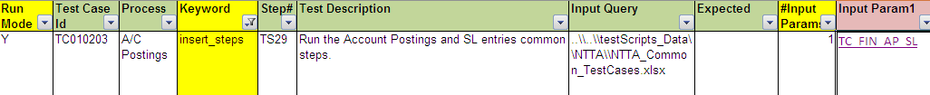

wait_time
Input | # of input params | Process/Purpose | Output | # of output params
Input Value: wait time in second | None | Wait time (Expected ) to process the next step | Passed or Failed | None

Test Step Example :

ui_steps
Input | # of input params | Process/Purpose | Output | # of output params
Input Query: spreadsheet name,  Input Params: the sheet name to run | Required | Call the UI Steps from the test case (Input Query)/ Sheet (Input Param1) | Passed or Failed | None

Test Step Example :

db_connect
Input | # of input params | Process/Purpose | Output | # of output params
Input Query: database name that need to connect | None | Forms an oracle connection string and connects to the database. | Passed or Failed | None

Test Step Example :

load_multi_data

Input | # of input params | Process/Purpose | Output | # of output params
Input Query: the spreadsheet contains the steps that want to insert to  Expected: "TOLLTAG_DATA" is a spreadsheet in test case excel file. | None | Support loading multi-data from spreadsheet | Passed or Failed | None

Test Step Example :

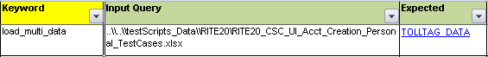

save_QryResults

Input | # of input params | Process/Purpose | Output | # of output params
Input Query: SQL query to get data from database | required | Run the SQL query and store the results in a file or to global variable array | Passed or Failed | none

Test Step Example :

webService_call

Input | # of input params | Process/Purpose | Output | # of output params
Input Params: params to input to webservice with specific url | required | Make a webService SOAP request call. | Passed or Failed | None

Test Step Example :

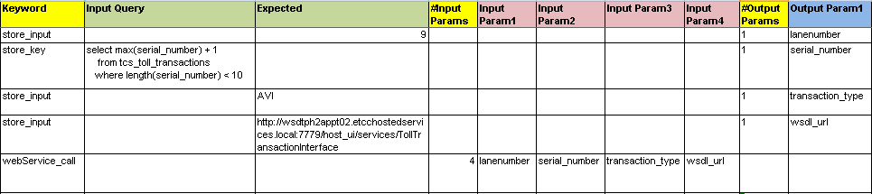

Web Automation Keywords

setup_browser
Input | # of input params | Process/Purpose | Output | # of output params
Input Value: Browser ID (IE, Chrome) | None | Choose the browser to run the system under test. | Passed or Failed | None

Test Step Example

load_page
Input | # of input params | Process/Purpose | Output | # of output params
Input Value: The URL to open. | None | Open/ load the page of system/ module/ function under test | Passed or Failed | None

Test Step Example

switch_frame
Input | # of input params | Process/Purpose | Output | # of output params
Input Value: The window/ frame (default/ contentFrame) | None | Selects either the main document, or the first frame on the page when a page contains iframes. | Passed or Failed | None

Test Step Example

enter_input
Input | # of input params | Process/Purpose | Output | # of output params
Input Value: the input string | None | Input the string to the control in UI. | Passed or Failed | None

Test Step Example

verify_element_present
Input | # of input params | Process/Purpose | Output | # of output params
Input Value: True/ False | None | Verify the element is avaiable or not avaiable in the UI. | - If input value is TRUE:  - Passed: the element is avaiable  - Failed: the element is not avaiable  - If input value is FALSE:  - Passed: the element is not avaiable  - Failed: the element is avaiable | None

Test Step Example 01: Input value is TRUE to verify balance money is avaiable

Test Step Example 02: Input value is FALSE to verify Subtotal do not exist on CSR’s screen

enter_input_hidden
Input | # of input params | Process/Purpose | Output | # of output params
Input Value: input String  OR  Input Params for the input string | Optional | Enter the value to input hidden field | Passed or Failed | None

Test Step Example:
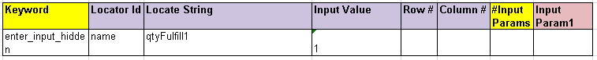
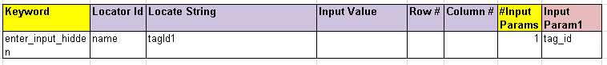

select_drop_down
Input | # of input params | Process/Purpose | Output | # of output params
nput Value: the string of item that want to select in drop down list  OR  Input Params for the input string for selected item | Optional | Input the value to the drop down list. | Passed or Failed | None

Test Step Example 01: No param

Test Step Example: using parameter in Input Param 1

Screenshot Example:
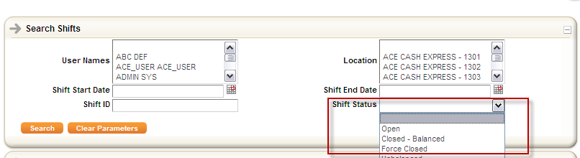

count_drop_down
Input | # of input params | Process/Purpose | Output | # of output params
Locator Id,  Locator String, | None | Count the number of items in drop down list and store in Output Param | Passed or Failed | Output Param1

Test Step Example:

click_element
Input | # of input params | Process/Purpose | Output | # of output params
Locator Id, Locator String | None | Clicks a web element on the page based on the locator id and string. | Pass or Fail | None

Test Step Example

verify_text
Input | # of input params | Process/Purpose | Output | # of output params
Input Value: the expected result (String)  OR  Input Param: the expected result (String) | 1 | Compare the value (text) of input element with expected result | Passed or Failed | None

Test Step Example 01: No param

Test Step Example: using Input Param 1

verify_text_contains
Input | # of input params | Process/Purpose | Output | # of output params
Input Value: the expected result (String)  OR  Input Param: the expected result (String) | None | Compare the text in html tag with expected result | Passed or Failed | None

Test Step Example :

verify_field_text
Input | # of input params | Process/Purpose | Output | # of output params
Input Value: the expected result (String)  OR  Input Param: the expected result (String) | None | Compare the text in text field with the expected result | Passed or Failed | None

Test Step Example :

compare_two_var
Input | # of input params | Process/Purpose | Output | # of output params
Input Param: 2,  Input Param1: variable 1,  Input Param2: variable 2 | 2 | Compare the value of variable 1 and variable 2 | Passed or Failed | None

Test Step Example :

verify_table_cell_text
Input | # of input params | Process/Purpose | Output | # of output params
Input value: the expected result (String),  Row: row number (start from 0)  Column: Colum number (start from 1) | None | Verify the text in cell (row, column) if it matchs with the expected result | Passed or Failed | None

Test Step Example :

table_row_sel
Input | # of input params | Process/Purpose | Output | # of output params
Input Value: True/ False  Row #: 0: started row,  Column#: the column to search the Input to select,  Input Param: Input string to search on data table | Optional | Select the row that matches with the string value | Output Params: Row number at selected item | 1st selected row

Test Step Example :

Screenshot Example :
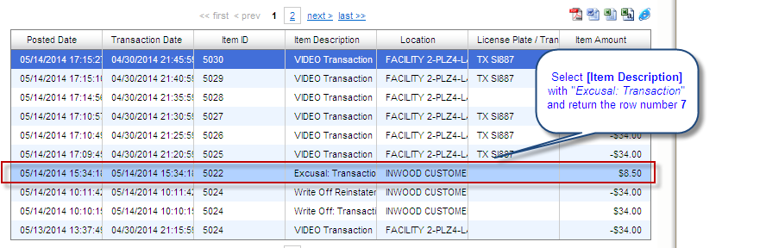

Input | # of input params | Process/Purpose | Output | # of output params
Locator Id,  Locator String | None | Count the number of rows and columns in table and store to Output Params | Row count and column count | Required
Test Step Example:

store_cell_data
Input | # of input params | Process/Purpose | Output | # of output params
Column: Column number,  Input Params: Row Number | None | Store the value in cell (Column, Row) to output param | Value in cell (column, row) | Output Param1

Test Step Example :

Screenshot Example :
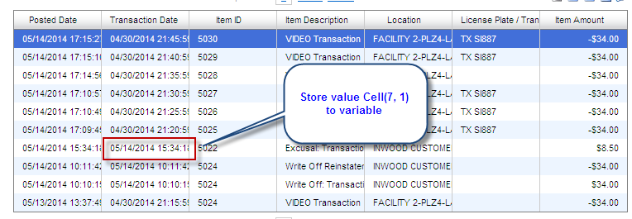

table_col_sort1
Input | # of input params | Process/Purpose | Output | # of output params
Locator Id,  Locator String | None | Click the table | Passed or Failed | None

Test Step Example :

table_col_sort2
Input | # of input params | Process/Purpose | Output | # of output params
Locator Id,  Locator String: Column ID | None | Sort the selected column | Passed or Failed | None

Test Step Example :

switch_alert_ok
Input | # of input params | Process/Purpose | Output | # of output params
None | None | Switch the window to alert pop up and click OK. | Passed or Failed | None

Test Step Example :

compare_JSAlert_msg
Input | # of input params | Process/Purpose | Output | # of output params
Input Value: expected string value  OR  Input Params: expected string value | None | Compare the value of java script alert with the string in Input Value (Input Param1) | Passed or Failed | None

Test Step Example :
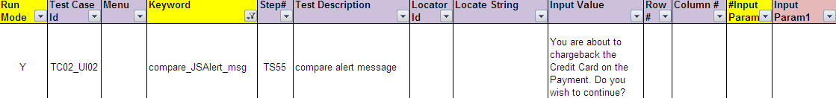

page_scroll
Input | # of input params | Scroll down the page so that webdriver detects elements. | Output | # of output params
Input Value: pixel value to scroll the page | None | Scroll down the page to X pixel  X: is defined as Input Value | Passed or Failed | None

Test Step Example :

screen_shot
Input | # of input params | Process/Purpose | Output | # of output params
Input Value: Screenshot name | None | Capture the current screen and save in ..\SelScripts\TestAuto_Framework\screenshots folder | Passed or Failed | None

Test Step Example :

wait_time
Input | # of input params | Process/Purpose | Output | # of output params
Input Value: wait time in second | None | Wait for next step | None | None

Test Step Example:

explicit_wait
Input | # of input params | Process/Purpose | Output | # of output params
Locator String: the element that need to see in UI  Input Value: wait time in second | None | Wait for the element is rendered in the UI. | Passed | None

Test Step Example:

store_data
Input | # of input params | Process/Purpose | Output | # of output params
Locator String: the element to get the data | None | Get the value from element and store to Output Param | The string value | None

Test Step Example :

store_input
Input | # of input params | Process/Purpose | Output | # of output params
Input Value: the input string | None | Store the input string (text) as variable | Passed or Failed | Output Param1
Test Step Example :

store_webTable_data
Input | # of input params | Process/Purpose | Output | # of output params
Table that store data | None | Store the data of the table on UI. This keyword is only used for report | None | Required

Test Step Example :

compare_webTable_DB
Input | # of input params | Process/Purpose | Output | # of output params
None | None | Compare the data in SQL query and data in the report | Passed or Failed | None

Test Step Example :

close_driver
Input | # of input params | Process/Purpose | Output | # of output params
None | None | Close the current window | Passed or Failed | None

Test Step Example :

quit_driver
Input | # of input params | Process/Purpose | Output | # of output params
None | None | Quits Selenium driver, closing every associated window. | Passed or Failed | None
Test Step Example :

verify_selectbox
Input | # of input params | Process/Purpose | Output | # of output params
Input Value: The input string to compare | None | This keyword is used to check the selected values in the box single or multiple. | Passed or Failed | None

Test Step Example: Verify current selected text of checkbox dateType is Posted Date

Keyword | Step# | Test Description | Locator Id | Locate String | Input Value
verify_selectbox | TS45 |  | id | dateType | Posted Date

Test Step Example: Multi SelectBox: Verify current selected texts of checkbox dateType is All and TX ABC774 (separate by delimiter ‘;’)

Keyword | Step# | Test Description | Locator Id | Locate String | Input Value
verify_selectbox | TS46 |  | id | licensePlates | All; TX ABC774

verify_checkbox
Input | # of input params | Process/Purpose | Output | # of output params
Input Value: check/uncheck/enable/disable | Required | This keyword will help us to verify if a checkbox is checked, unchecked, enabled or disabled. | Passed or Failed | None

Test Step Example:
BE sheet
Keyword | Step# | Test Description | Input Query | Expected | #Output Params | Output Param1
store_key | TS02 |  | select 'All' from dual |  | 1 | All_value
store_key | TS02 |  | select 'Account' from dual |  | 1 | Account_value

UI sheet
Keyword | Step# | Test Description | Locator Id | Locate String | Input Value | #Input Params | Input Param1 | Note
verify_checkbox | TS40 |  | id | itemGroups | check | 1 | All_value | verify checkbox All is checked
verify_checkbox | TS40 |  | id | itemGroups | enable | 1 | All_value | verify checkbox All is enable
verify_checkbox | TS40 |  | id | itemGroups | uncheck | 1 | Account_value | verify checkbox Account is unchecked
verify_checkbox | TS40 |  | id | itemGroups | disable | 1 | Account_value | verify checkbox Account is disable

deselect_drop_down
Input | # of input params | Process/Purpose | Output | # of output params
Locator ID/ Locate String | None | De-select the default value(s) in the drop down/select box as below screen shot | Passed or Failed | None
Test Step Example:
Keyword | Step# | Test Description | Locator Id | Locate String | Input Value | Row # | Column # | #Input Params | Input Param1
deselect_drop_down | TS01 | De-select all | id | employeeIdStd

verify_field_text_contains
Input | # of input params | Process/Purpose | Output | # of output params
Input Value: input string | Optional | Compare the value (text) of expected result contains input element | Passed or Failed | None

Test Step Example: Test cases require to check the default value of UI Date input is equal to system date in dd/mm/yyyy HH24. We need a key word to verify the content we get from UI in in dd/mm/yyyy HH24:MI:SS format and the date time variable we get from DB.
Keyword | Step# | Test Description | Locator Id | Locate String | Input Value | #Input Params | Input Param1
verify_field_text_contains | TS01 | Verify the date in text field and system variable in dd/mm/yyyy HH24 format | id | someId |  | 1 | sys_date

store_field_text
Input | # of input params | Process/Purpose | Output | # of output params
Input Value: Locate String |  | Get value from text field and store in a variable | The value from text field | required

Test Step Example:
Run Mode | Test Case Id | Menu | Keyword | Step# | Test Description | Locator Id | Locate String | #Output Params | Output Param1
Y | TC02_UI_03 |  | store_field_text | TS32 | Get the total amount being excused | xpath | .//*[@id='totalAmountExcuse'] | 1 | total_amount_temp

concatenate_var
Input | # of input params | Process/Purpose | Output | # of output params
Input Value: the string that want to concatenate |  | Concatenate multi strings into one variable | The combine string | required

Test Step Example:
Run Mode | Test Case Id | Keyword | Step# | Test Description | #Input Params | Input Param1 | Input Param2 | Input Param3 | #Output Params | Output Param1
Y | TC02_UI_03 | concatenate_var | TS33 | Combine variable before with variable store with variable after | 3 | variable_before | total_amount_temp | variable_after | 1 | total_amount

get_text_split
Input | # of input params | Process/Purpose | Output | # of output params
Input value: the character (string) to recognize split position  Input Param: String to be split |  | Split the text separated by any delimiter into two values and stores in two variables. | The split strings | required

Test Step Example:

Run Mode | Test Case Id | Keyword | Step# | Test Description | Input Value | #Input Params | Input Param1 | #Output Params | Output Param1 | Output Param2
Y | TC02_UI02 | get_text_split | TS57 | This will split the text separated by any delimiter into two values and stores in two variables | <space> | 1 | tc02_last_date_act12 | 2 | tc02_last_date1_act12 | tc02_last_date2_act12

store_webTable_data
Input | # of input params | Process/Purpose | Output | # of output params
 | None | Store web table data in a two dimensional vector to compare in compare_webTable_DB

Test Step Example:
Run Mode | Test Case Id | Menu | Keyword | Step# | Test Description | Locator Id | Locate String
Y | CSC12_UI02 |  | store_webTable_data | TS26 | store_webTable_data | xpath | /html/body/table

compare_webTable_DB
Input | # of input params | Process/Purpose | Output | # of output params
Array 1 |  | Compare two variables in columns Input Param1 and Output Param1. |  | required

Test Step Example:
Run Mode | Test Case Id | Menu | Keyword | Step# | Test Description | #Input Params | Input Param1 | #Output Params | Output Param1
Y | CSC01_UI02 |  | compare_webTable_DB | TS35 | compare_webTable_DB | 1 | array1 | 1 | array2

table_RowsCols_count

Input | # of input params | Process/Purpose | Output | # of output params
None |  | Count number of rows and columns of a table and store in output parameters |  | required

Test Step Example:

Run Mode | Test Case Id | Menu | Keyword | Step# | Test Description | Locator Id | Locate String | Input Value
Y | TC03_UI04 |  | Table_RowsCols_count | TS147 | Get total rows of assignments table | xpath | .//*[@id='upAssignments']/table/tbody/tr/td[2]/table/tbody/tr[2]/td/table | TC0304_Actual_Total_Assignments

table_row_del

Input | # of input params | Process/Purpose | Output | # of output params
None | none | Count number of rows and columns of a table and store in output parameters |  | none

Test Step Example:

Run Mode | Test Case Id | Keyword | Step# | Test Description | Locator Id | Locate String | Row#
Y | TC03_UI04 | table_row_del | TS60 | Give the table locator string that you are interested in. Also, give the row you want to delete. | xpath | //div[@id='edit_employee']/table[2]/tbody/tr[5]/td | 3

JSAlert_options

Input | # of input params | Process/Purpose | Output | # of output params
OK | required | OK Alert Button |  | none
Cancel | required | Cancel Alert Button |  | none

Test Step Example:

Run Mode | Test Case Id | Keyword | Step# | Test Description | Locator Id | Locate String | Row#
Y | TC03_UI04 | table_row_del | TS60 | Give the table locator string that you are interested in. Also, give the row you want to delete. | xpath | //div[@id='edit_employee']/table[2]/tbody/tr[5]/td | 3

Run Mode | Test Case Id | Keyword | Step# | Test Description | #Input Params | Input Param1
Y | TC03_UI04 | JSAlert_options | TS036 | Cancel Alert | 1 | cancel

Run Mode | Test Case Id | Keyword | Step# | Test Description | #Input Params | Input Param1
Y | TC03_UI04 | JSAlert_options | TS036 | OK Alert | 1 | OK

popup_scroll

Input | # of input params | Process/Purpose | Output | # of output params
Element position | none | Scroll to specific web element |  | none

Test Step Example:

Run Mode | Test Case Id | Menu | Keyword | Step# | Test Description | Locator Id | Locate String | Input Value
Y | TC02_UI01 |  | Popup_scroll | TS27 | Scroll to specific element | id | panelWindow | 400

start_loop

Input | # of input params | Process/Purpose | Output | # of output params
Element Position | required | Start loop from the specific line |  | None

Test Step Example:

Run Mode | Test Case Id | Keyword | Step# | Test Description | #Input Params | Input Param1 | Input Param2
Y | TC03_UI01 | Start_loop | TS75 | Start loop from specific line to line | 2 | 10 | 204

end_loop

Input | # of input params | Process/Purpose | Output | # of output params
none | none | End the loop to support reading multi-data |  | none

Test Step Example:

Run Mode | Test Case Id | Keyword | Step# | Test Description
Y | TC03_UI01 | end_loop | TS75 | End the loop to support reading multi-data

enter_input_query

Input | # of input params | Process/Purpose | Output | # of output params
SQL Query | required | Execute the query in the input |  | none

Test Step Example:

Run Mode | Test Case Id | Keyword | Step# | Test Description | Input Value | #Input Params | Input Param1
Y | TC08_UI02 | Enter_input_query | TS66 | Execute the query in the input | SELECT * FROM ACCOUNT WHERE account_id = ? | 1 | Account_id

switch_window

Input | # of input params | Process/Purpose | Output | # of output params
none |  | Switch to opened window or switch back to parent window |  | None
default | 1 | Switch to default window. |  | None

Test Step Example:

Run Mode | Test Case Id | Keyword | Step# | Test Description
Y | TC02_UI01 | switch_window | TS66 | Switch to opened window

Run Mode | Test Case Id | Keyword | Step# | Test Description
Y | TC02_UI01 | switch_window | TS69 | Switch back to parent window

Run Mode | Test Case Id | Keyword | Step# | Test Description | Input Value
Y | TC08_UI02 | switch_window | TS66 | Get default window handle | default

screen_shot_popup_window

Input | # of input params | Process/Purpose | Output | # of output params
Screenshot name |  | Capture screenshot of pdf file displayed in web browser | Screenshot file | none

Test Step Example:

Run Mode | Test Case Id | Keyword | Step# | Test Description | Input Value
Y | TC02_UI01 | screen_shot_popup_window | TS94 | Take screenshot | Exported to PDF File

send_key

Input | # of input params | Process/Purpose | Output | # of output params
Keyboard button action | none | Simulation keyboard action base on input value |  | none

Test Step Example:

Run Mode | Test Case Id | Keyword | Step# | Test Description | Input Value
Y | TC05_UI01 | Send_key | TS24 | Keyboard action | Enter

select_dropdown_options

Input | # of input params | Process/Purpose | Output | # of output params
Input Value: input String.  OR  Input Params for the input string  Or None for all options  The format of the input should be separate by comma for every option: option1,option2 |  | Select one or multiple or all options at the same time | - If input value is a string:  - Passed: the options are selected  - Failed: the option is not selected  - If input value is null:  - Passed: All options are selected  - Failed: All options are not selected.

Test Step Example:

Run Mode | Test Case Id | Keyword | Step# | Test Description | Input Value
Y | TC03_UI01 | Select_Dropdown_options | TS94 | Select all available options.

Run Mode | Test Case Id | Keyword | Step# | Test Description | Locator Id | Locate String | Input Value
Y | TC14_UI | select_dropdown_options | TS25 | select options | id | accountPlansAvailableOptions | option1,option2

Run Mode | Test Case Id | Keyword | Step# | Test Description | Locator Id | Locate String | #Input Params | Input Param1
Y | TC14_UI | select_dropdown_options | TS25 | Select all available options | id | accountPlansAvailableOptions | 1 | tc_14_avail_account_type_plan

hold_ctrl_key

Input | # of input params | Process/Purpose | Output | # of output params
Option list | none | Simulate hold and release Ctrl key to select multi rows in tables |  | none

Test Step Example:

Run Mode | Test Case Id | Keyword | Step# | Test Description | Input Value
Y | TC02_UI01 | hold_ctrl_key | TS76 | Press “Ctrl” button | press

Run Mode | Test Case Id | Keyword | Step# | Test Description | Input Value
Y | TC02_UI01 | hold_ctrl_key | TS76 | Release “Ctrl” button | release

